 | 10.1.15 Editors - Compositor Editor - Header - Add Menu - Vector
Table of content
Detailed table of content 1
Add menu - Vector 3
Combine XYZ 3
Separate XYZ 3
Normal 4
Vector Curves 4

Detailed table of content
Detailed table of content
Detailed table of content 1
Add menu - Vector 3
Combine XYZ 3
Input 3
X Y and Z 3
Output 3
Color 3
Separate XYZ 3
Input 3
Vector 3
Output 3
X, Y and Z 3
Normal 4
Inputs 4
Normal 4
Properties 4
Normal Direction 4
Outputs 4
Normal 4
Dot 4
Vector Curves 4
Inputs 4
Vector 4
Properties 5
Channel 5
Channel buttons 5
Curve edit field 5
Selecting Points 5
Adding Points 5
Navigation elements 5
Zoom in and out 5
Tools 5
Reset View 5
Vector Handle 5
Auto Handle 5
Auto Clamped Handle 5
Extend horizontal 5
Extend extrapolated 6
Reset Curve 6
Use Clipping 6
Delete Points 6
Outputs 6
Vector 6

Add menu - Vector
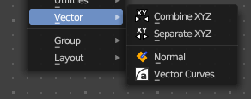
Here you find mainly nodes for vector data manipulation.

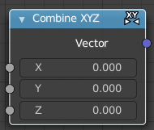
Combine XYZ
Same as with Combine RGB node. It combines color values. But instead combining rgb values, which are in the range of 0 to 255, it uses values in the range from 0 to 1.

Input

X Y and Z
X, Y and Z values.

Output

Color
Color output.

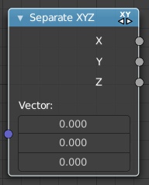
Separate XYZ
Same as with Separate RGB node. It separates color values. But instead separating rgb values, which are in the range of 0 to 255, it uses a vector with the values in the range from 0 to 1.

Input

Vector
The Input vector.

Output

X, Y and Z
The output vectors for X, Y and Z

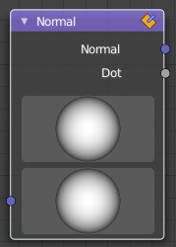
Normal
The Normal node generates a normal vector and a dot product.

Inputs

Normal
Normal vector input.

Properties

Normal Direction
To manually set a fixed normal direction vector. LMB click and drag on the sphere to set the direction of the normal. Holding Ctrl while dragging snaps to 45 degree rotation increments.

Outputs

Normal
Normal vector output.

Dot
Dot product output. The dot product is a scalar value.
If two normals are pointing in the same direction the dot product is 1.
If they are perpendicular the dot product is zero (0).
If they are anti parallel (facing directly away from each other) the dot product is -1.

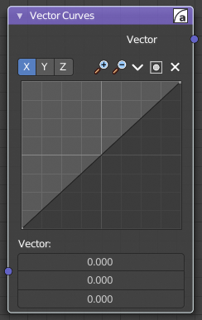
Vector Curves
The Vector Curves node maps an input vector components to a curve.

Inputs
In the shader context the node also has an additional Factor property.

Vector
Standard vector input.

Properties

Channel

Channel buttons
X, Y, Z. Clicking on one of the channels displays the curve for each.

Curve edit field
Create and tweak a Bezier curve that varies the input levels (X axis) to produce an output level (Y axis).


Selecting Points
You can select curve points. This reveals two edit boxes for the x and y coordinate of this point.
Selected points can be moved around. Left click at them, hold the mouse button down and move them to a new location.


Adding Points
You can add new curve points by simply left clicking at the curve. Move the mouse to position them where you need it.

Navigation elements
The navigation elements at the top are described from left to right.

Zoom in and out
The two buttons with the magnifying glass at it zooms in and out in the curve window.

Tools

Tools is a menu where you can find some curve related tools.

Reset View
Resets the curve windows zoom.

Vector Handle
Set handle type to Vector.

Auto Handle
Set handle type to Auto.

Auto Clamped Handle
Set handle type to Auto Clamped.

Extend horizontal
Extends the curve before the first curve point and behind the last curve point horizontally.

Extend extrapolated
Extends the curve before the first curve point and behind the last curve point extrapolated.

Reset Curve
Resets the curve to the initial shape.


Use Clipping
Clipping options. Set up clipping for the stroke.

Delete Points
Deletes selected curve points.

Outputs

Vector
Standard vector output.

